APPLICATION FORM
_______ I would like for my child to be a student in the Wilson County Inclusive Early Childhood Pilot Program.
_____ I would like to be contacted to discuss the Wilson County Inclusive Early Childhood Pilot Program.
______________________________ Name of Preschool Child
_______________________________
Birthdate of Child
_______________________________
Address
________________________________
City, State, Zip Code
________________________________Parent’s Name
_______________________________ Daytime Telephone or Cell Phone
________________________________Evening Phone
________________________________
School District
________________________________
School Year
This pilot project will provide children who are grouped heterogeneously the opportunity to interact and learn from each other as well as to gain greater understanding of human diversity and its value to our society. All students benefit from carefully designed instruction that meets their individual levels. In addition, students:
- Are taught by highly qualified early childhood teachers
- Have a challenging learning environment
- Learn to appreciate individual needs of students with special learning needs
- Will increase self-confidence
- Develop friendships with children with a variety of learning abilities
- Have more positive self-images by learning from and teaching each other
For more information, contact:
Student Services-Jane Jones
P.O. Box 555
Wilson, VA 22000
Phone: 800.5551212
Fax: 800.555.1234

WILSON COUNTY
PUBLIC SCHOOLS

INCLUSIVE
EARLY CHILDHOOD PILOT PROGRAM
The Wilson County Public Schools Early Childhood Pilot Program is committed to:
- Student achievement
- Pursuit of lifelong learning
- Personal Responsibility
- High Quality of Life
- Equal Opportunities

for ALL

PROJECT DESCRIPTION
Inclusive classrooms consist of equal numbers of same-aged children with and without disabilities attending classes together. The Wilson County Inclusive Early Childhood classes will be in session Wednesday and Thursday beginning as soon as possible. Class hours will be from 9:00 a.m. to 1:30 p.m.
Selection criteria are listed below:
- Consideration will be given to children living in Wilson County
- Children must be at least 3 years old
- Children must be toilet trained
- Children must enjoy the company of other children
Only those children meeting the criteria will be considered. The number of students selected will be based on the make-up of the Early Childhood Special Education class. Notification letters will be sent to parents.

PARENT RESPONSIBILITIES
We believe that parents are the primary facilitators of their child’s development. The Wilson County Inclusive Early Childhood Pilot Program will offer many opportunities for families to participate in the early childhood learning environment.
If your child is selected to participate in the program, it will be necessary for parents to:
- Attend a parent orientation
- Supply items on the preschool supply list
- Apply and be eligible for the free/reduced lunch program
- Volunteer services for the class as needed
Transportation needs will be considered on an individual basis.
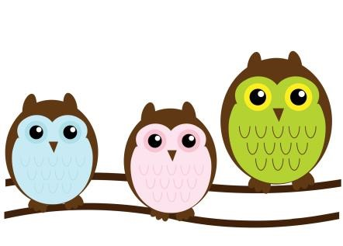

HOW TO APPLY
To apply, fill out the application section on this brochure and return to the Early Childhood Coordinator. Once selections have been made, parents will be notified as to acceptance. An orientation meeting will be held prior to enrollment.
If your child is selected to participate in the
Wilson County Inclusive Early Childhood Pilot Program, the parent must present the following documents in order to register the child in school:
- A current state physical examination record
- A current immunization record
- Proof of residency in Wilson
- Birth certificate
- Completed USDA food application

